**Федеральное государственное бюджетное образовательное**

**учреждение высшего профессионального образования**

**«Алтайский государственный технический университет**

**им. И. И. Ползунова»**

**Факультет (институт) информационных технологий**

**Кафедра Прикладная математика**

**Отчет защищен с оценкой____________**

**____________________ В.А.Крайванова**

**(подпись преподавателя) (инициалы, фамилия)**

**“____”__________ 2017 г.**

**Отчет**

**по лабораторной (практической) работе №2**

**«PHP Silex»**

**(название лабораторной (практической) работы)**

**по дисциплине Современные средства промышленной разработки ПО**

**(наименование дисциплины)**

**ЛР 09.03.04.05.000 ОТ**

**(обозначение документа)**

**Студенты группы ПИ-32        Е.А. Волков**

**(инициалы, фамилия)**

**Преподаватель доцент, к. ф.-м. н.  В.А.Крайванова**

**должность, ученое звание (инициалы, фамилия)**

**БАРНАУЛ 2017**

*Задание (вариант 5)*

1. **Общее задание:**

Реализовать CRUD для одной из сущностей из лабораторной работы 1 с использованием фреймворка PHP Silex и шаблонов из лабораторной работы 1.

1. **Задание по варианту:**

База данных редких растений Алтайского края. Для каждого растения хранится описание, исследователи, заповедники, статус.

1. **Решение:**

**Исходный Код вёрстки**

Файл index.php

**<?php**

**// web/index.php**

**require_once __DIR__.'/../vendor/autoload.php';**

**use Symfony\Component\HttpFoundation\Request;**

**use Symfony\Component\HttpFoundation\Response;**

**Request::enableHttpMethodParameterOverride();**

**$app = new Silex\Application();**

**$app['debug'] = true;**

**$app->register(new Silex\Provider\TwigServiceProvider(),**

**['twig.path' => __DIR__ . '/../view']);**

**$app->register(new Silex\Provider\DoctrineServiceProvider(),**

**['db.options' => ['driver' => 'pdo_mysql', 'dbname' => 'plants', 'charset' => 'utf8']]);**

**$app->get('/', function () use ($app) {**

**/**@var $conn Connection */**

**$conn = $app['db'];**

**$division = $conn->fetchAll('select * from division');**

**return $app['twig']->render('index.twig', ['division' => $division]);**

**});**

**$app->get('/division/{id}', function ($id) use ($app) {**

**/**@var $conn Connection */**

**$conn = $app['db'];**

**$division = $conn->fetchAll('select * from division');**

**$plants = $conn->fetchAll('select * from plants_table where division = ?', [$id]);**

**$reservation = $conn->fetchAll('select * from reservation');**

**$status = $conn->fetchAll('select * from status');**

**$pl_rsrvtn = $conn->fetchAll('select * from plants_reservation');**

**$dvs = $conn->fetchAssoc('select * from division where id = ?', [$id]);**

**return $app['twig']->render('plants_in_division.twig', ['plants' => $plants,**

**'dvs' => $dvs,**

**'division' => $division,**

**'status' => $status,**

**'reservation' => $reservation,**

**'pl_rsrvtn' => $pl_rsrvtn]);**

**});**

**$app->get('/division/{div}/plants/{id}', function (Request $req, $div, $id) use ($app) {**

**$conn = $app['db'];**

**$division = $conn->fetchAll('select * from division');**

**$plant = $conn->fetchAssoc('select * from plants_table where id = ?', [$id]);**

**$reservation = $conn->fetchAll('select * from reservation');**

**$status = $conn->fetchAll('select * from status');**

**$pl_rsrvtn = $conn->fetchAll('select * from plants_reservation');**

**$dvs = $conn->fetchAssoc('select * from division where id = ?', [$plant["division"]]);**

**return $app['twig']->render('edit_plant.twig', ['plant' => $plant,**

**'division' => $division,**

**'dvs' => $dvs,**

**'status' => $status,**

**'reservation' => $reservation,**

**'pl_rsrvtn' => $pl_rsrvtn]);**

**});**

**$app->put('/division/{div}/plants/{id}', function (Request $req, $div, $id) use ($app) {**

**$conn = $app['db'];**

**$rus_name = $req->get('rus_name');**

**$lat_name = $req->get('lat_name');**

**$info = $req->get('info');**

**$sec_measures = $req->get('sec_measures');**

**$status = $req->get('status');**

**$name_reservations = $req->get('reservation');**

**$status_id = $conn->fetchAssoc('select id from status where name = ?', [$status]);**

**$conn->update('plants_table',**

**['rus_name' => $rus_name,**

**'lat_name' => $lat_name,**

**'info' => $info,**

**'sec_measures' => $sec_measures,**

**'status_id' => $status_id["id"],],**

**['id' => $id]);**

**$pl_rsrvtn = $conn->fetchAll('select * from plants_reservation');**

**foreach ($pl_rsrvtn as $key)**

**{**

**if ($key["plants_id"] == $id)**

**$conn->delete('plants_reservation', ['id' => $key['id']]);**

**}**

**$rsrv_id = $conn->fetchAssoc('select id from reservation where name = ?', [$name_reservations]);**

**if ($rsrv_id)**

**$conn->insert('plants_reservation', ['plants_id' => $id, 'reservation_id' => $rsrv_id["id"]]);**

**return $app->redirect("/division/".$div);**

**});**

**$app->post('/plants/{dvs_id}', function (Request $req, $dvs_id) use ($app) {**

**$conn = $app['db'];**

**$rus_name = $req->get('rus_name');**

**$lat_name = $req->get('lat_name');**

**$info = $req->get('info');**

**$sec_measures = $req->get('sec_measures');**

**$status = $req->get('status');**

**$name_reservations = $req->get('reservation');**

**$status_id = $conn->fetchAssoc('select id from status where name = ?', [$status]);**

**$conn->insert('plants_table', ['rus_name' => $rus_name,**

**'lat_name' => $lat_name,**

**'info' => $info,**

**'sec_measures' => $sec_measures,**

**'status_id' => $status_id["id"],**

**'division' => $dvs_id]);**

**$id = $conn->fetchAssoc('select id from plants_table where rus_name = ?', [$rus_name]);**

**$rsrv_id = $conn->fetchAssoc('select id from reservation where name = ?', [$name_reservations]);**

**//var_dump($rsrv_id);**

**if ($rsrv_id)**

**$conn->insert('plants_reservation', ['plants_id' => $id["id"], 'reservation_id' => $rsrv_id["id"]]);**

**return $app->redirect('/division/'.$dvs_id);**

**});**

**$app->delete('/division/{div}/plants/{id}', function ($div, $id) use ($app) {**

**$conn = $app['db'];**

**$pl_rsrvtn = $conn->fetchAll('select * from plants_reservation');**

**foreach ($pl_rsrvtn as $key)**

**{**

**if ($key["plants_id"] == $id)**

**$conn->delete('plants_reservation', ['id' => $key['id']]);**

**}**

**$conn->delete('plants_table', ['id' => $id]);**

**return $app->redirect('/division/'.$div["id"]);**

**});**

**$app->run();**

Файл base.twig:

<!DOCTYPE html>

<html lang="en">

<head>

<meta charset="utf-8">

<meta http-equiv="X-UA-Compatible" content="IE=edge">

<meta name="viewport" content="width=device-width, initial-scale=1">

<!-- The above 3 meta tags *must* come first in the head; any other head content must come *after* these tags -->

<meta name="description" content="">

<meta name="author" content="">

<link rel="icon" href="../favicon.ico">

<title>Красная Книга Алтая</title>

<!-- Bootstrap core CSS -->

<link href="/css/bootstrap.min.css" rel="stylesheet">

<!-- IE10 viewport hack for Surface/desktop Windows 8 bug -->

<link href="/assets/css/ie10-viewport-bug-workaround.css" rel="stylesheet">

<!-- Custom styles for this template -->

<link href="/carousel.css" rel="stylesheet">

<link href="/blog.css" rel="stylesheet">

</head>

<body>

<div class="navbar-wrapper">

<div class="container">

<nav class="navbar navbar-inverse navbar-static-top">

<div class="container">

<div class="navbar-header">

<button type="button" class="navbar-toggle collapsed" data-toggle="collapse" data-target="#navbar" aria-expanded="false" aria-controls="navbar">

<span class="sr-only">Toggle navigation</span>

<span class="icon-bar"></span>

<span class="icon-bar"></span>

<span class="icon-bar"></span>

</button>

<a class="navbar-brand" href="#">Красная книга</a>

</div>

<div id="navbar" class="navbar-collapse collapse">

<ul class="nav navbar-nav">

<li class=""><a href="/">Главная</a></li>

<li class="dropdown">

<a href="#" data-toggle="dropdown" class="dropdown-toggle">

Виды растений

<b class="caret"></b>

</a>

<ul class="dropdown-menu">

{% for dvs in division %}

<li><a href="/division/{{ dvs.id }}">{{ dvs.name }}</a></li>

{% endfor %}

</ul>

</ul>

</div>

</div>

</nav>

</div>

</div>

{% block content %}{% endblock %}

<div class="container">

<!-- FOOTER -->

<footer>

<p class="pull-right"><a href="#">Back to top</a></p>

<p>&copy; 2016 Volkov E.A. <br>e-mail: egoralvolk@gmail.com</p>

</footer>

</div>

<!-- Just for debugging purposes. Don't actually copy these 2 lines! -->

<!--[if lt IE 9]><script src="../../assets/js/ie8-responsive-file-warning.js"></script><![endif]-->

<script src="/assets/js/ie-emulation-modes-warning.js"></script>

<!-- Bootstrap core JavaScript

================================================== -->

<!-- Placed at the end of the document so the pages load faster -->

<script src="https://ajax.googleapis.com/ajax/libs/jquery/1.12.4/jquery.min.js"></script>

<script>window.jQuery || document.write('<script src="./assets/js/vendor/jquery.min.js"><\/script>')</script>

<script src="/js/bootstrap.min.js"></script>

<!-- IE10 viewport hack for Surface/desktop Windows 8 bug -->

<script src="/assets/js/ie10-viewport-bug-workaround.js"></script>

<script src="offcanvas.js"></script>

</body>

</html>

Файл edit_plant.twig

{% extends "base.twig" %}

{% block content %}

<div class="container">

<form id="edit" method="POST" action="/division/{{dvs.id}}/plants/{{plant.id}}" ">

<input type="hidden" id="_method" name="_method" value="PUT">

<div class="blog-header">

<h1>Добавление нового растения</h1>

</div>

<div class="row">

<div class="col-xs-12 col-sm-12">

<div class="row">

<div class="form-group col-sm-6">

<label for="inputName">Название</label>

<input name="rus_name" id="inputName" class="form-control" type="text" value="{{plant.rus_name}}">

</div>

<div class="form-group col-sm-6">

<label for="inputLatName">Латинское название</label>

<input name="lat_name" id="inputLatName" class="form-control" type="text" value="{{plant.lat_name}}">

</div>

</div>

<div class="row">

<div class="form-group col-sm-6">

<label for="information">Описание</label>

<textarea name="info" class="form-control" id="information" rows="8">{{plant.info}}</textarea>

<style type="text/css">

#information { resize: none; }

</style>

</div>

<div class="form-group col-sm-6">

<label for="measures">Меры охраны</label>

<textarea name="sec_measures" class="form-control" id="measures" rows="8"> {{plant.sec_measures}}</textarea>

<style type="text/css">

#measures { resize: none; }

</style>

</div>

</div>

<div class="row">

<div class="form-group col-sm-6">

<label for="status">Статус растения</label>

<select name="status" class="form-control col-sm-6" id="status">

{% for st in status %}

{% if st.id == plant.status_id%}

<option selected="selected">{{st.name}}</option>

{% else %}

<option>{{st.name}}</option>

{% endif %}

{% endfor %}

</select>

</div>

<div class="form-group col-sm-6">

<label for="multiSelect">Охраняется в</label>

<select name="reservation" class="form-control" multiple="multiple" id="multiSelect">

{% for pr in pl_rsrvtn %}

{% if pr%}

{% if plant.id == pr.plants_id%}

{% for res in reservation %}

{% if pr.reservation_id == res.id %}

<option selected="selected">{{res.name}}</option>

{% else %}

<option>{{res.name}}</option>

{% endif %}

{% endfor %}

{% endif %}

{% endif %}

{% endfor %}

</select>

</div>

</div>

</div>

</div>

<div class="row">

<button type="button" class="btn btn-default">Закрыть</button>

<button type="submit" class="btn btn-primary">Сохранить</button>

</div>

</form>

</div><!--/.container-->

{% endblock %}

Файл index.twig

{% extends "base.twig" %}

{% block content %}

<div class="container">

<form id="edit" method="POST" action="/division/{{dvs.id}}/plants/{{plant.id}}" ">

<input type="hidden" id="_method" name="_method" value="PUT">

<div class="blog-header">

<h1>Добавление нового растения</h1>

</div>

<div class="row">

<div class="col-xs-12 col-sm-12">

<div class="row">

<div class="form-group col-sm-6">

<label for="inputName">Название</label>

<input name="rus_name" id="inputName" class="form-control" type="text" value="{{plant.rus_name}}">

</div>

<div class="form-group col-sm-6">

<label for="inputLatName">Латинское название</label>

<input name="lat_name" id="inputLatName" class="form-control" type="text" value="{{plant.lat_name}}">

</div>

</div>

<div class="row">

<div class="form-group col-sm-6">

<label for="information">Описание</label>

<textarea name="info" class="form-control" id="information" rows="8">{{plant.info}}</textarea>

<style type="text/css">

#information { resize: none; }

</style>

</div>

<div class="form-group col-sm-6">

<label for="measures">Меры охраны</label>

<textarea name="sec_measures" class="form-control" id="measures" rows="8"> {{plant.sec_measures}}</textarea>

<style type="text/css">

#measures { resize: none; }

</style>

</div>

</div>

<div class="row">

<div class="form-group col-sm-6">

<label for="status">Статус растения</label>

<select name="status" class="form-control col-sm-6" id="status">

{% for st in status %}

{% if st.id == plant.status_id%}

<option selected="selected">{{st.name}}</option>

{% else %}

<option>{{st.name}}</option>

{% endif %}

{% endfor %}

</select>

</div>

<div class="form-group col-sm-6">

<label for="multiSelect">Охраняется в</label>

<select name="reservation" class="form-control" multiple="multiple" id="multiSelect">

{% for pr in pl_rsrvtn %}

{% if pr%}

{% if plant.id == pr.plants_id%}

{% for res in reservation %}

{% if pr.reservation_id == res.id %}

<option selected="selected">{{res.name}}</option>

{% else %}

<option>{{res.name}}</option>

{% endif %}

{% endfor %}

{% endif %}

{% endif %}

{% endfor %}

</select>

</div>

</div>

</div>

</div>

<div class="row">

<button type="button" class="btn btn-default">Закрыть</button>

<button type="submit" class="btn btn-primary">Сохранить</button>

</div>

</form>

</div><!--/.container-->

{% endblock %}

Файл plants_in_division.twig

{% extends "base.twig" %}

{% block content %}

<div class="modal fade" data-modal-color="lightgreen" id="EditModal" tabindex="-1" role="dialog" aria-labelledby="myModalLabel">

<div class="modal-dialog" role="document">

<div class="modal-content">

<div class="modal-header">

<button type="button" class="close" data-dismiss="modal" aria-label="Close"><span aria-hidden="true">&times;</span></button>

<h4 class="modal-title">Редактирование информации о растении</h4>

</div>

<form id="edit" method="POST" action="/plants/{{dvs.id}}" ">

<div class="modal-body">

<div class="row row-offcanvas row-offcanvas-right">

<div class="col-xs-12 col-sm-12">

<div class="row">

<div class="form-group col-sm-6">

<label for="inputName">Название</label>

<input name="rus_name" id="inputName" class="form-control" type="text">

</div>

<div class="form-group col-sm-6">

<label for="inputLatName">Латинское название</label>

<input name="lat_name" id="inputLatName" class="form-control" type="text">

</div>

</div>

<div class="row">

<div class="form-group col-sm-6">

<label for="information">Описание</label>

<textarea name="info" class="form-control" id="information" rows="8"></textarea>

<style type="text/css">

#information { resize: none; }

</style>

</div>

<div class="form-group col-sm-6">

<label for="measures">Меры охраны</label>

<textarea name="sec_measures" class="form-control" id="measures" rows="8"></textarea>

<style type="text/css">

#measures { resize: none; }

</style>

</div>

</div>

<div class="row">

<div class="form-group col-sm-6">

<label for="status">Статус растения</label>

<select name="status" class="form-control col-sm-6" id="status">

{% for st in status %}

<option>{{st.name}}</option>

{% endfor %}

</select>

</div>

<div class="form-group col-sm-6">

<label for="multiSelect">Охраняется в</label>

<select name="reservation" class="form-control" multiple="multiple" id="multiSelect">

{% for rsv in reservation %}

<option>{{rsv.name}}</option>

{% endfor %}

</select>

</div>

</div>

</div>

</div>

</div>

<div class="modal-footer">

<button type="button" class="btn btn-default" data-dismiss="modal">Закрыть</button>

<button type="submit" class="btn btn-primary">Сохранить</button>

</div>

</form>

</div>

</div>

</div>

<div class="modal fade" data-modal-color="lightgreen" id="AddModal" tabindex="-1" role="dialog" aria-labelledby="myModalLabel">

<div class="modal-dialog" role="document">

<div class="modal-content">

<div class="modal-header">

<button type="button" class="close" data-dismiss="modal" aria-label="Close"><span aria-hidden="true">&times;</span></button>

<h4 class="modal-title">Добавление нового растения</h4>

</div>

<form method="POST" action="/plants/{{dvs.id}}" ">

<div class="modal-body">

<div class="row row-offcanvas row-offcanvas-right">

<div class="col-xs-12 col-sm-12">

<div class="row">

<div class="form-group col-sm-6">

<label for="inputName">Название</label>

<input name="rus_name" id="inputName" class="form-control" type="text">

</div>

<div class="form-group col-sm-6">

<label for="inputLatName">Латинское название</label>

<input name="lat_name" id="inputLatName" class="form-control" type="text">

</div>

</div>

<div class="row">

<div class="form-group col-sm-6">

<label for="information">Описание</label>

<textarea name="info" class="form-control" id="information" rows="8"></textarea>

<style type="text/css">

#information { resize: none; }

</style>

</div>

<div class="form-group col-sm-6">

<label for="measures">Меры охраны</label>

<textarea name="sec_measures" class="form-control" id="measures" rows="8"></textarea>

<style type="text/css">

#measures { resize: none; }

</style>

</div>

</div>

<div class="row">

<div class="form-group col-sm-6">

<label for="status">Статус растения</label>

<select name="status" class="form-control col-sm-6" id="status">

{% for st in status %}

<option>{{st.name}}</option>

{% endfor %}

</select>

</div>

<div class="form-group col-sm-6">

<label for="multiSelect">Охраняется в</label>

<select name="reservation" class="form-control" multiple="multiple" id="multiSelect">

{% for rsv in reservation %}

<option>{{rsv.name}}</option>

{% endfor %}

</select>

</div>

</div>

</div>

</div>

</div>

<div class="modal-footer">

<button type="button" class="btn btn-default" data-dismiss="modal">Закрыть</button>

<button type="submit" class="btn btn-primary">Создать</button>

</div>

</form>

</div>

</div>

</div>

<div class="container">

<div class="blog-header">

<h1 class="blog-title">{{dvs.name}}

<button type="button" class="btn btn-default" data-toggle="modal" data-target="#AddModal">

Добавить

</button>

</h1>

<p class="lead blog-description">{{dvs.annotation}}</p>

</div>

<div class="row">

<div class="col-sm-12 blog-main">

{% for plant in plants %}

<div class="blog-post">

<h2 class="blog-post-title">{{plant.rus_name}} </h2>

<p class="blog-post-meta">{{plant.lat_name}}

<form method="POST" action="/division/{{dvs.id}}/plants/{{plant.id}}">

<input type="hidden" name="_method" value="GET">

<button type="submit" class="btn btn-default">Редактировать</button>

</form>

<form method="POST" action="/division/{{dvs.id}}/plants/{{plant.id}}">

<input type="hidden" name="_method" value="DELETE">

<button type="submit" class="btn btn-danger">Удалить</button>

</form>

</p>

<h3>Описание</h3>

<p>{{plant.info}}</p>

<h3>Меры охраны</h3>

<p>{{plant.sec_measures}}</p>

<h3>Статус -

{% for st in status %}

{% if st%}

{% if plant.status_id == st.id %}

{{ st.name}}</h3>

<p>{{st.info}}</p>

{% endif %}

{% endif %}

{% endfor %}

<h3>Места охраны</h3>

{% for pr in pl_rsrvtn %}

{% if pr%}

{% if plant.id == pr.plants_id%}

{% for res in reservation %}

{% if pr.reservation_id == res.id %}

<p> {{ res.name }} </p>

{% endif %}

{% endfor %}

{% endif %}

{% endif %}

{% endfor %}

</div>

{% endfor %}

</div><!-- /.blog-main -->

</div>

</div><!--/.container--> {% endblock %}

**Cкриншоты верстки**

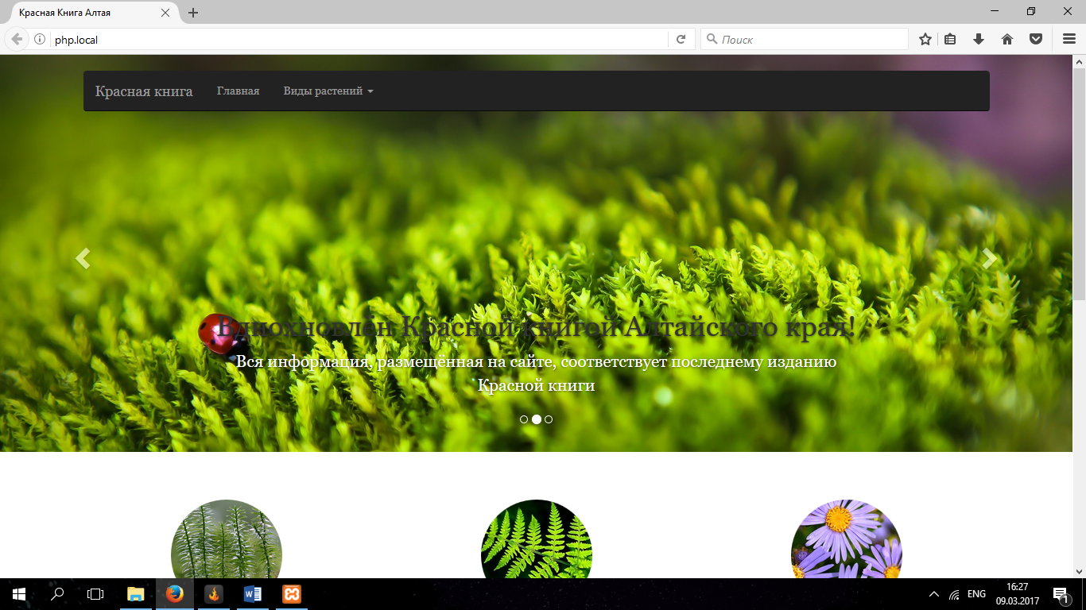

Рисунок 1 – Главная страница

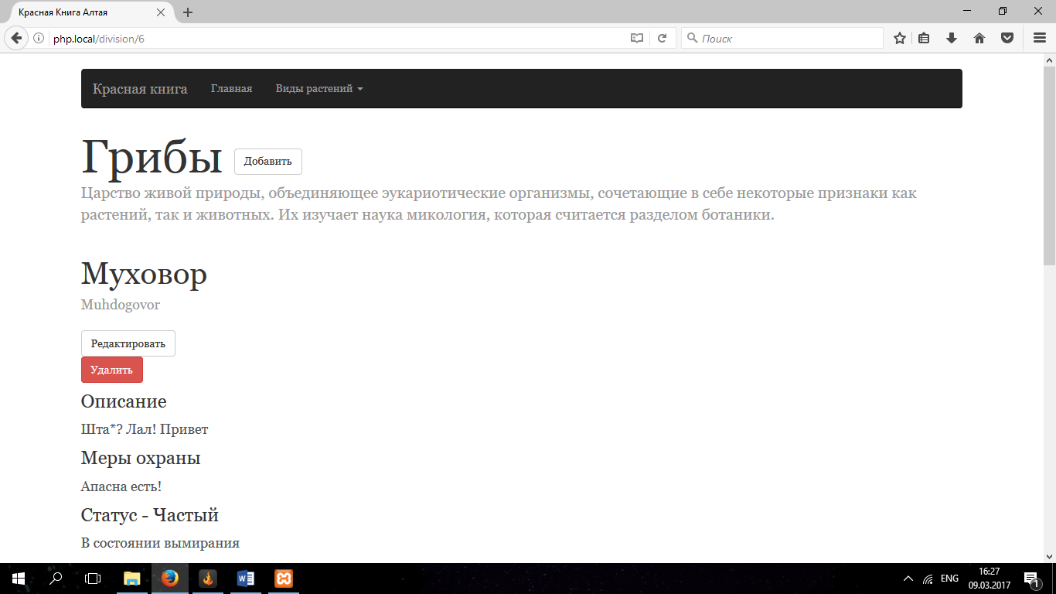

Рисунок 2 – Страница просмотра растений

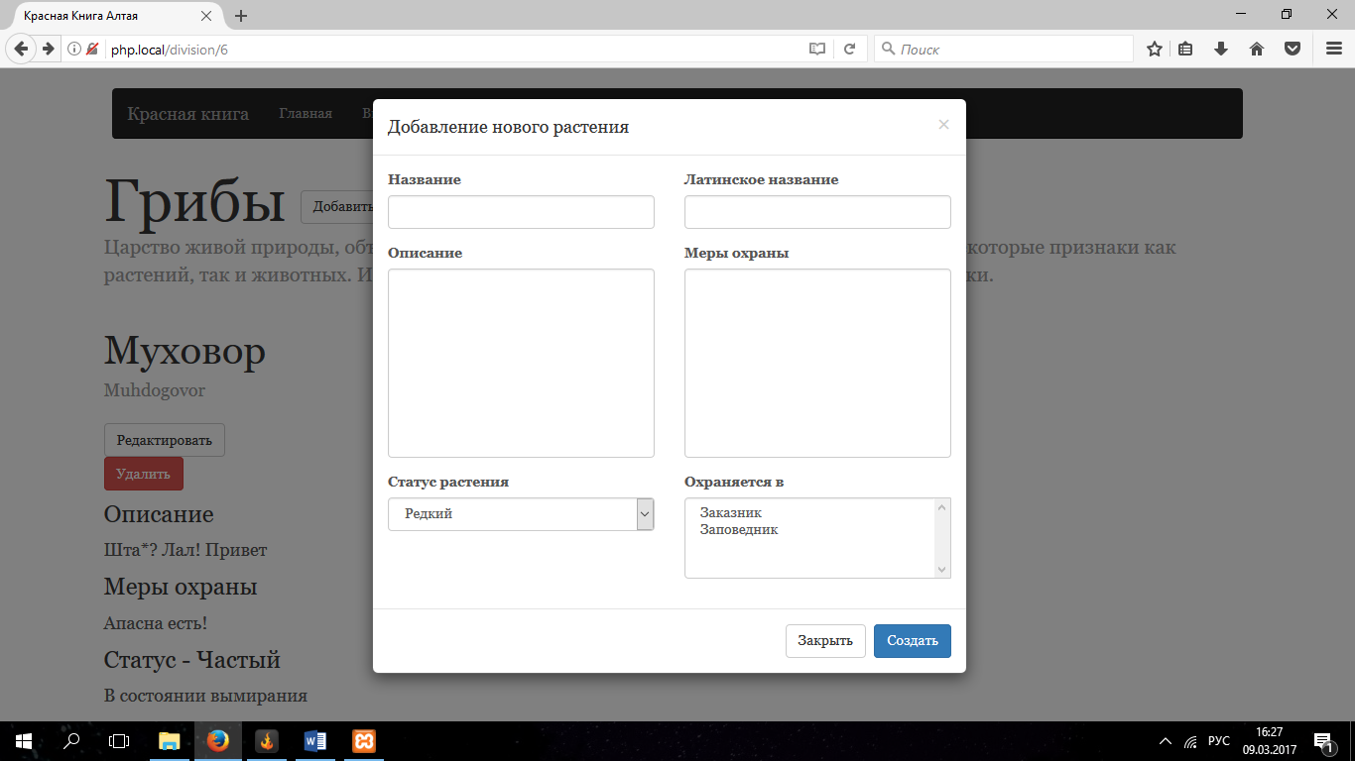

Рисунок 3 – Добавление нового растения

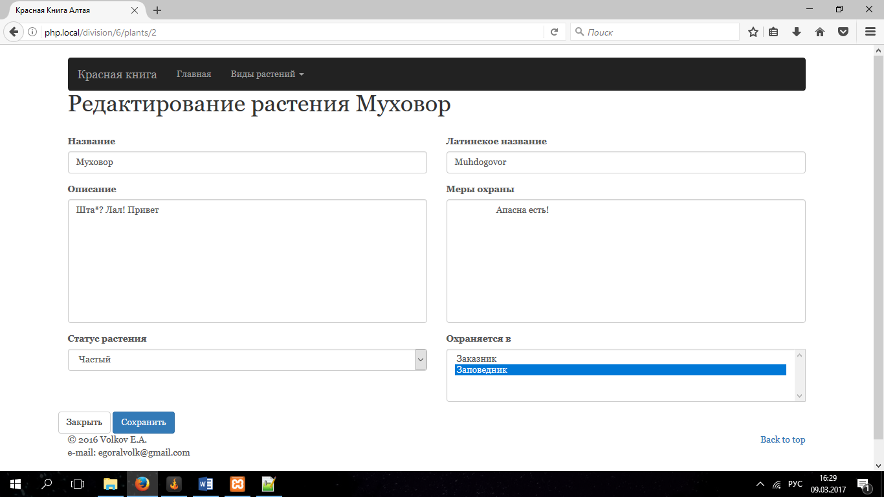

Рисунок 4 – Страница редактирования растения